### Current Activities

Following on from the busy period over the summer, things have quietened down at Hursley. We have been in “consolidation mode”, with lots of tidying up and cataloguing.

We have also turned our attention to documenting some of those things we older ex-employees can remember while we still can! We are pulling together the story of the rise and fall of the punch card, with some detail on the processes and hardware involved. This will appear on the museum web site, accompanied by a trifold summarising these processes as a lead-in for visitors. We do actually have a full suite of Unit Record hardware at Hursley. If only it was all in good working order!

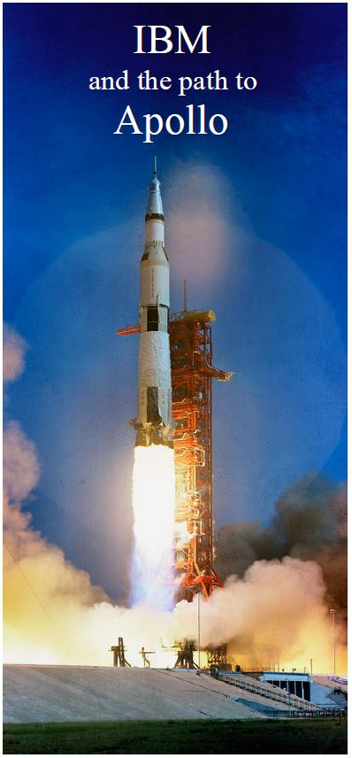Also to be published imminently is a trifold of IBM’s involvement in the U.S. space programme and particularly Apollo.

### Other

TnMOC’s Peter Vaughan has been approached by a film company looking to make a documentary about “Silicon Glen” with a main focus on IBM’s Spango Valley plant. He has passed this on to us to see if we can also help. I know they have an 1130 at TnMOC which was almost certainly built in Greenock.

Peter Short spent 11 years based in Greenock so may be able to contribute memories. The museum also has quite a number of artefacts made in Greenock.